Monitor de vía – Dashboard
Saba - Adif
Support note

 | Author | Date
Creation | DVERA | 26/05/2025
Last Revision | DVERA | 23/09/2026
DOCUMENT REVISIONS

Revision | Date | Author | Pages | Modifications
1 | 26/05/2025 | DVERA | All | Dashboard configuration.
2 | 23/09/2026 | DVERA | All | Document translated to English. Installation replaced by a reference to the Installation manual. Connection tab updated (auto brightness, car counter, Testing connection way). New Resources file and Testing tabs. Edit current config updated (UPDATE button).

Content
General description 4
System requirements 4
Application installation 4
Access to and handling of the device 4
1. Integrated services 4
Integrated FTP server 4
2. Web configuration panel 7
Access to the web configurator 8
Description of the main sections (tabs) 9
Editing the configuration 15

General description
This application is designed to be installed on the 55'' lane monitors (Monitor de vía) located in car parks, both indoors and outdoors. Its main purpose is to show relevant information on the monitor and to make the remote management of files and configurations easier.

System requirements
- Device: 55'' monitor with Android 9 or Android 12.
- Accessories: Remote control, keyboard and/or mouse (optional).
- Network: Connection to the same local network to access the integrated services.
- Developer options: Required to install the application over the network (ADB) and to view the monitor remotely with Vysor.

Application installation
- Installer package: The application is installed, updated and uninstalled over the local network with the installer package supplied with each release (ADB over the network). It is no longer necessary to copy the APK file to a USB memory.
- The complete procedure (preparing the display, first start permissions, setting the application as default home, updates, uninstall and troubleshooting) is described in the document “Installation manual”.

Access to and handling of the device
- Remote control: Allows handling the basic functions of the display, for example to grant the permissions on first start and to set the application as the default home application.
- Keyboard and mouse: Can be connected to the USB ports to make it easier to configure the IP address of the display.

Integrated services

Integrated FTP server
Allows the remote management of files from any computer connected to the same network, using an FTP client or directly the Windows file explorer. In this example we use winSCP.
Access:
- Android 9:
  - Port 2121: access to the root directory of the device.
  - Main folder: Documents/Dashboard/
- Android 12:
  - Port 2122: direct access to the application folder.
Main directories:
- Images: Pictures/Dashboard/
- Videos: Video/Dashboard/
- Configuration files and logs: according to the internal structure.
Note:
The application must be installed and running for the FTP service to work.

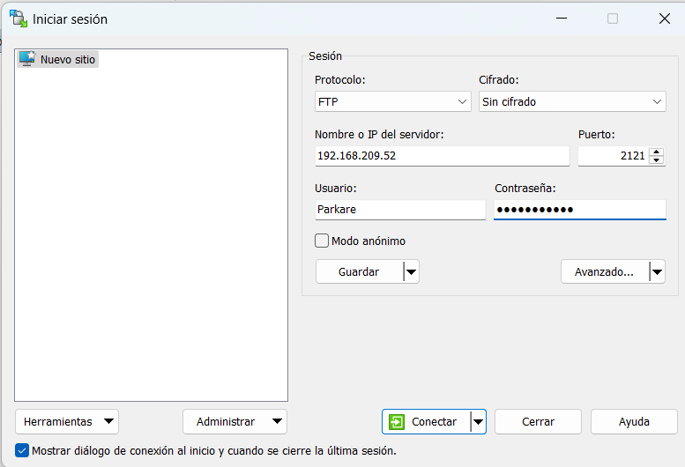
WinSCP FTP client accessing the root of the device (example: 192.168.209.52) on port 2121 with the user: Parkare and the password: Parking2010
To access the configuration files or the logs on Android 12 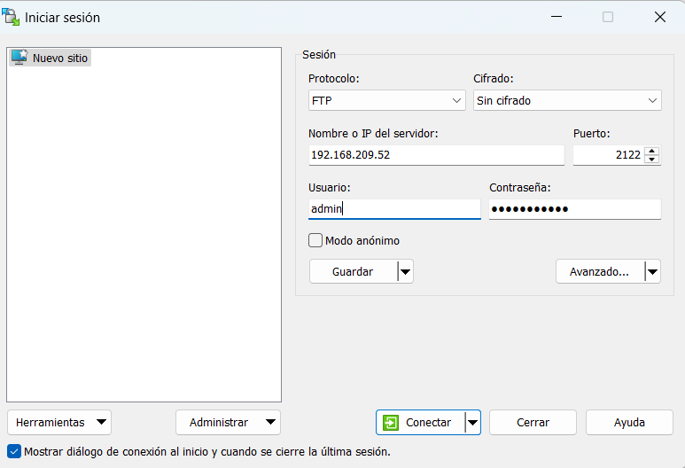
WinSCP FTP client accessing the private folder of the application to view the logs or the configuration files (example: 192.168.209.52) on port 2122 with the user: admin and the password: Parking2010

Main uses:
- Add images and videos to show on the monitor.
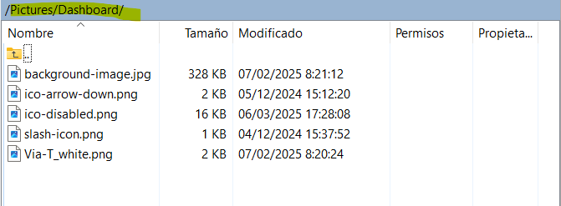

- Manually modify the configuration files (ftp_connection.json, connection_config.json, screen_config.json).
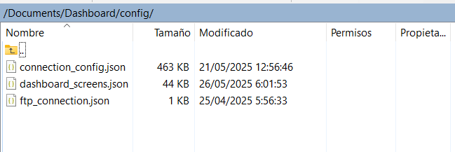
Access to the configuration files on an Android 9 device on port 2121
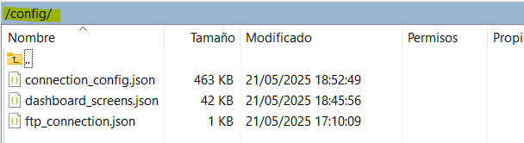
Access to the configuration files on an Android 12 device on port 2122

- Download the log files for diagnosis.
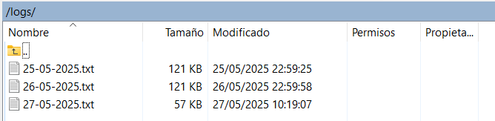
Access to the logs on an Android 12 device on port 2122
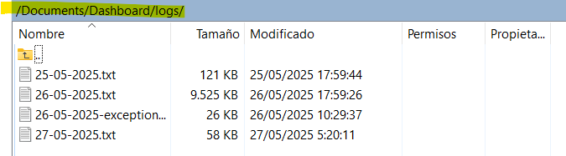
Access to the logs on an Android 9 device on port 2121

Web configuration panel
The web configurator is the central tool for the maintenance and remote customisation of the application installed on the lane monitors. It allows modifying the connection parameters, managing configurations and resources, editing and testing screens and sharing settings between different devices, all through an interface accessible from any computer connected to the same local network.

Access to the web configurator
- To access it, open a web browser such as Google Chrome and enter the IP address of the monitor followed by port 8080 (for example: http://192.168.1.100:8080).
- On the initial screen (“Choose what do you wanna do”), select “Go to dashboard setting panel”.
- A password is requested to enter the configuration panel (Parking2010)
- Once authenticated, a side menu with eight main tabs is shown. At the bottom of the side menu you can select the IP address of the monitor to configure, and the application version is shown.
Tab | Functionality
Connection | Configures the connection way, terminal IP and port, API, language delay, text size, auto brightness, car counter and video frame.
Dashboard list | Manages the list of monitors and replicates configurations to other monitors.
Export | Shows and downloads configurations and templates.
Import | Loads and applies configurations or templates. Allows editing before saving.
Edit current config | Shows and edits the screens and their elements graphically (texts, images, colours, etc.).
Share config | Shares configurations with other monitors, shows the connection status and allows selecting the screens to share.
Resources file | Uploads, downloads and deletes the images, and uploads the fonts (Regular, Medium and Bold) used by the screens.
Testing | Sends any configured screen to the monitor, with test values for its data, to check it directly on the device.
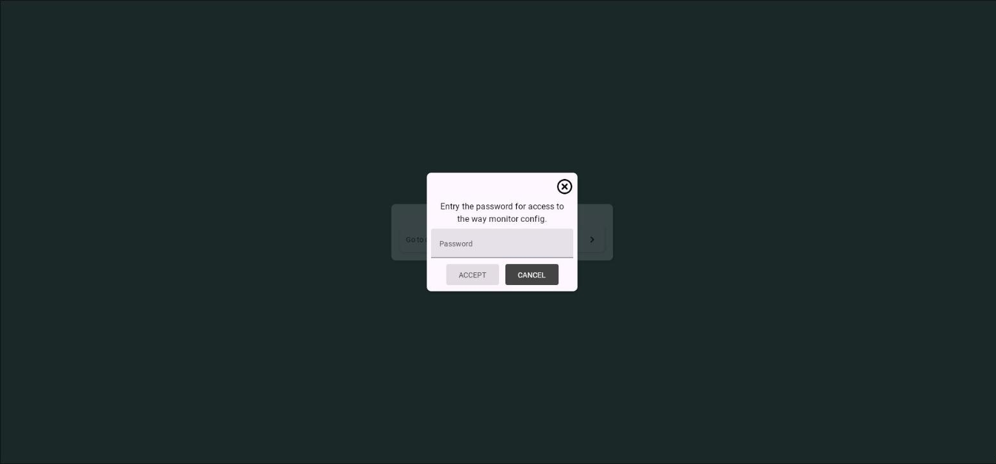 | 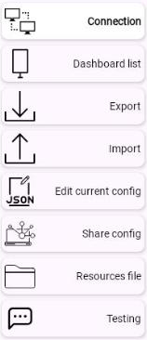
Initial screen of the configurator when accessing through the IP address of the monitor | Options of the main configuration menu

Description of the main sections (tabs)

Connection
Defines the connection parameters and the basic configuration of the monitor:
- Connection way: Selects how the monitor communicates with the parking terminal (SignalR or Socket). The “Testing” option does not connect to the terminal and lets you show any configured screen from the Testing tab.
- Terminal IP and port: Address and port of the parking terminal the monitor communicates with.
- API: Field used only in SignalR mode.
- Delay time(s): Time in seconds to alternate between the languages configured on screen.
- Show video frame: Shows a video frame at the bottom of the screen. The videos must be stored in the folder Videos/Dashboard/.
- Text size scale: Adjusts the overall size of the texts shown on screen.
- Set auto brightness change: When enabled, the screen is dimmed after the monitor has shown the idle screen (IDLE) for the number of seconds set in “Active low brightness after(s)”. The screen is restored as soon as the terminal sends a new event.
- Show car counter: Shows on screen a counter of the vehicles authorised to pass (event 12, PLEASE_PROCEED). The counter is reset every “Reset counter each (minutes)” minutes.
- When finished, press “SAVE” to apply the changes on the monitor immediately.
- Note: The images are no longer managed in this tab. They are managed in the “Resources file” tab.

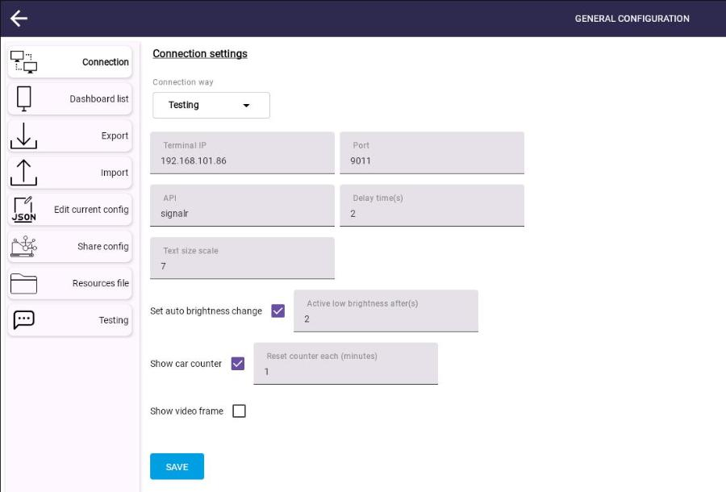
Connection settings screen: connection to the terminal and operating properties of the monitor

Dashboard list
Manages a list of lane monitors for centralised administration:
- Adds new monitors with their IP address, a custom name and, optionally, the IP address of the associated terminal.
- Allows replicating the current configuration to other monitors of the list.
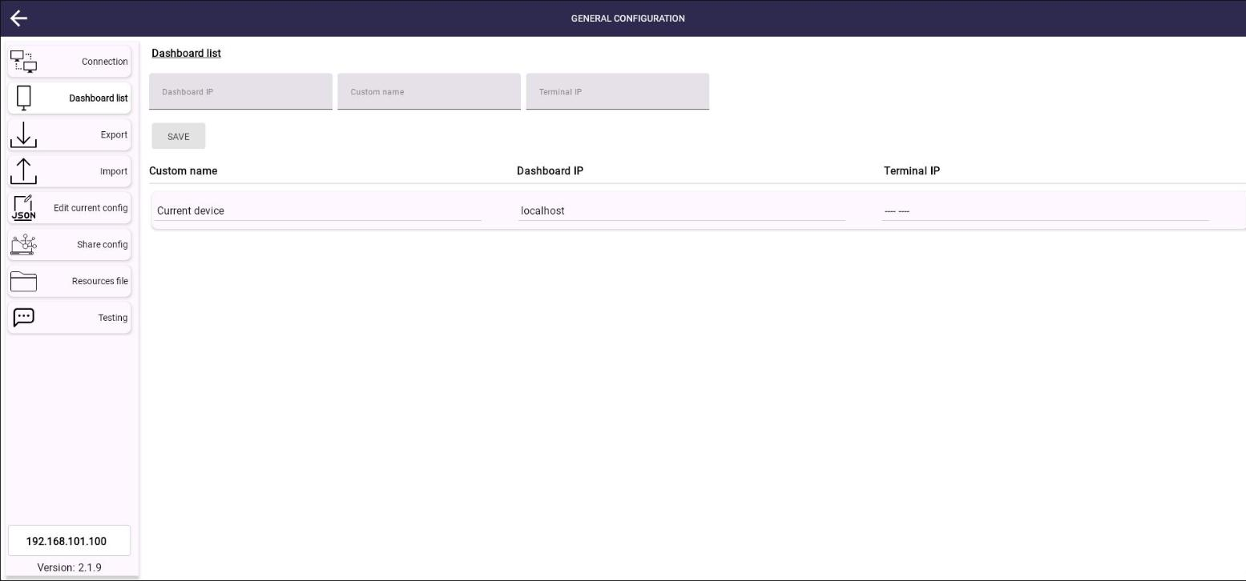
Device management screen (lane monitors)

Export
Downloads the current configuration and predefined templates:
- Shows and downloads the active configuration.
- Downloads templates for different scenarios (entry with ticket, ticketless exit, etc.) from a drop-down list.
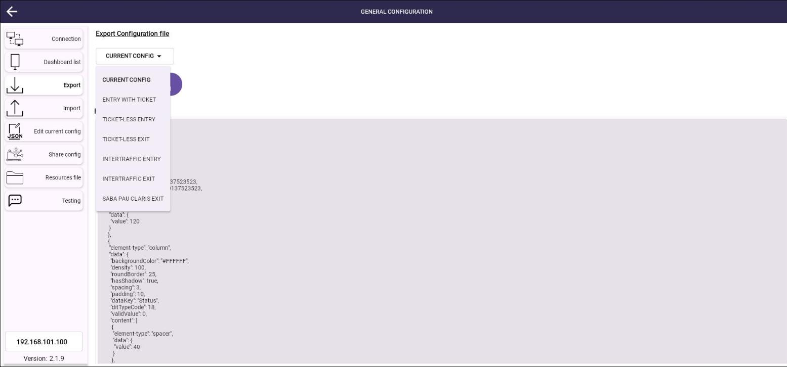
Screen to export the current configuration or a predefined template

Import
Loads previously saved configurations or templates:
- Upload a configuration file or select a template from the list.
- Edit the configuration before applying it.
- Press “SAVE” to update the monitor with the new configuration.
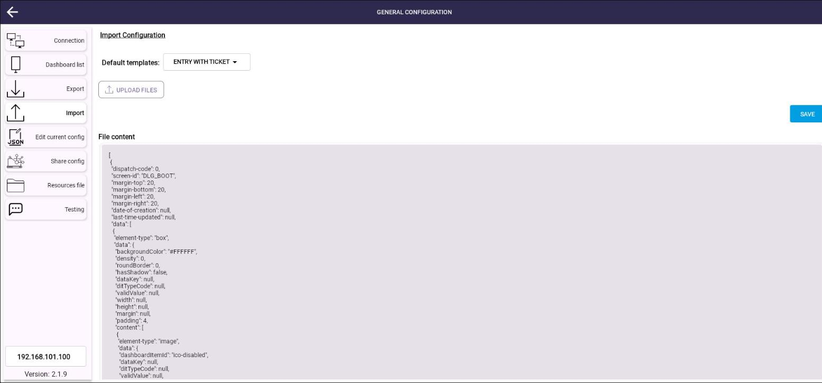
Configuration import screen: a file with the correct format can be selected and viewed; if the format is not correct, the application shows an error message

Edit current config
Graphic tool to edit the screens and their visual elements:
- Screen list (left): shows the configured screens. Select one to load it in the screen preview.
- Screen preview (centre): shows the selected screen. Click an element to load its code.
- Element code (right): allows editing the properties of the selected element directly in JSON (texts, colours, sizes, etc.).
- Button “UPDATE”: applies the changes to the selected element and, after accepting the confirmation message, saves the configuration on the monitor.
Note: If the confirmation message is cancelled, the changes are not saved on the monitor.

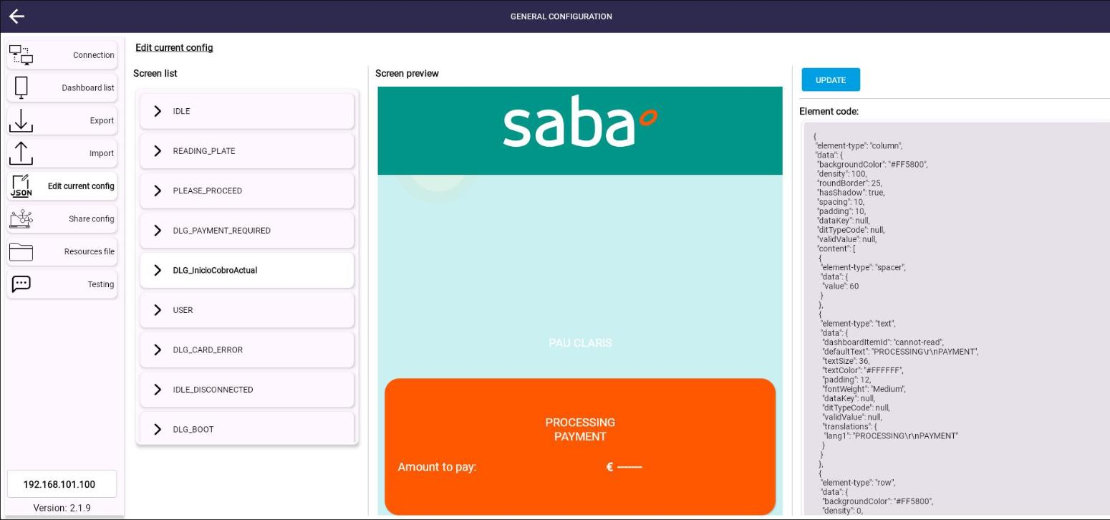
Edit current config screen, editing the “PROCESSING PAYMENT” text of the DLG_InicioCobroActual screen

Share config
Shares configurations between monitors:
- Shows the list of available monitors with a connection indicator.
- Allows selecting specific screens to share, with a preview.
- Button “SHARE”: sends the selected configuration to the chosen monitors, after confirming the password.
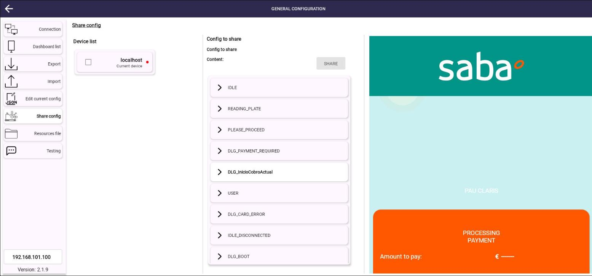
“Share config” screen showing the device list, the screens loaded in the configuration and the graphic preview of the selected screen
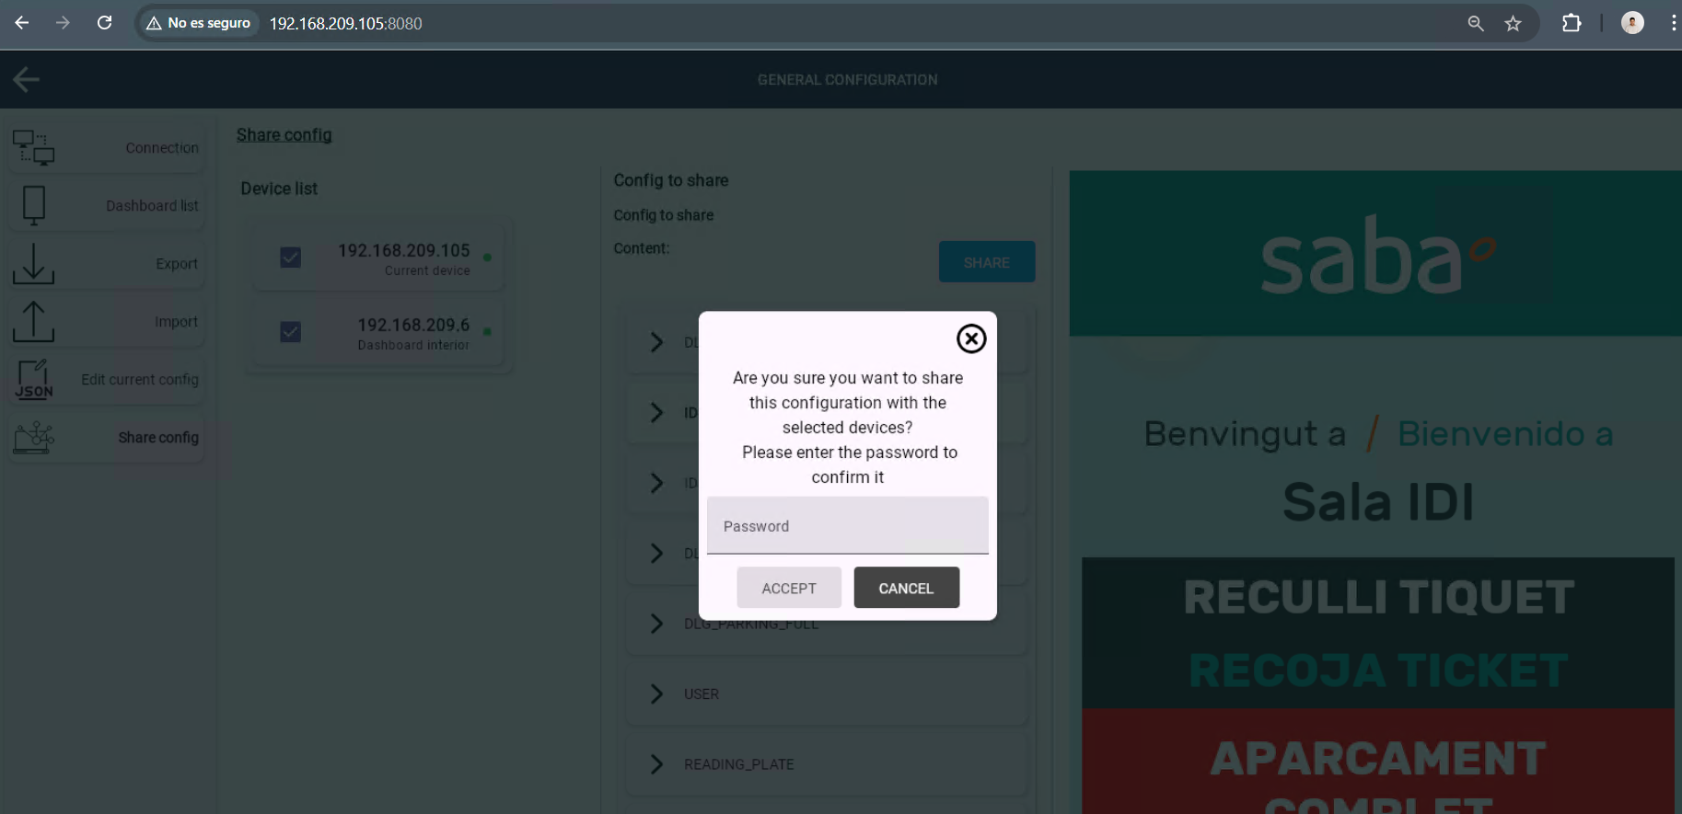
Password screen to share the current configuration of the device “192.168.209.105” with the device “192.168.209.6”; use the password “Parking2010”

Resources file
Manages the resource files used by the screens. The tab has two panels:
- Image resources: shows the images stored on the monitor. “UPLOAD FILES” adds one or more images, the “x” button deletes an image and the arrow button downloads it. The images must keep their original name to be recognised by the application (for example, background-image for the background). Press “SAVE” to apply the changes on the monitor.
- Font resources: select the font weight (REGULAR, MEDIUM or BOLD) and press “UPLOAD FILES” to upload the font file for that weight (.ttf, .otf or .ttc). The font is saved and applied immediately; each weight has one file, so uploading a new file replaces the previous one. The texts of the screens use the weight set in their “fontWeight” property.

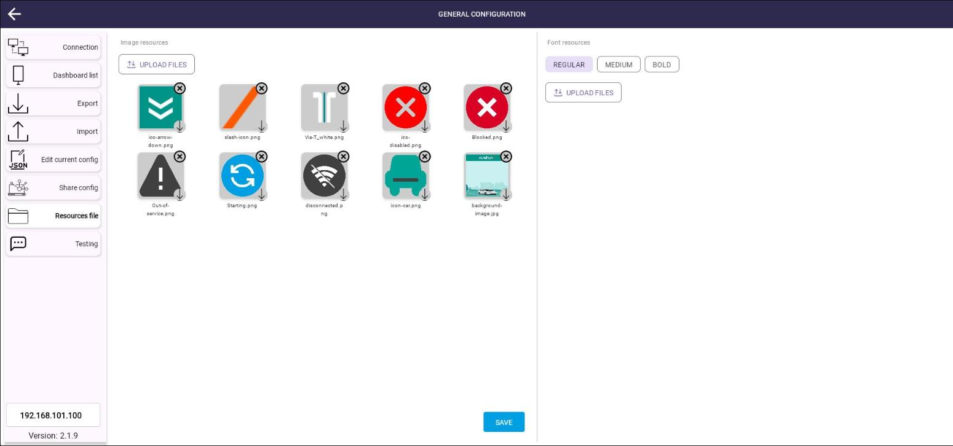
Resources file screen: images stored on the monitor (left) and font files by weight (right)

Testing
Allows testing the configured screens directly on the monitor, without a parking terminal:
- In the Connection tab, select the connection way “Testing” and press “SAVE”. The monitor stops listening to the terminal and waits for the events sent from this tab.
- The “Screen list” shows all the screens of the current configuration with their event code. Select the screen to test.
- If the screen uses data sent by the terminal (for example, the amount to pay, the card reader or the licence plate), a form is shown for each DIT with its fields. Fill in all the fields with the test values.
- Press “SEND”: the monitor shows the selected screen with the values entered.
- When the tests are finished, set the connection way back to SignalR or Socket and press “SAVE”.

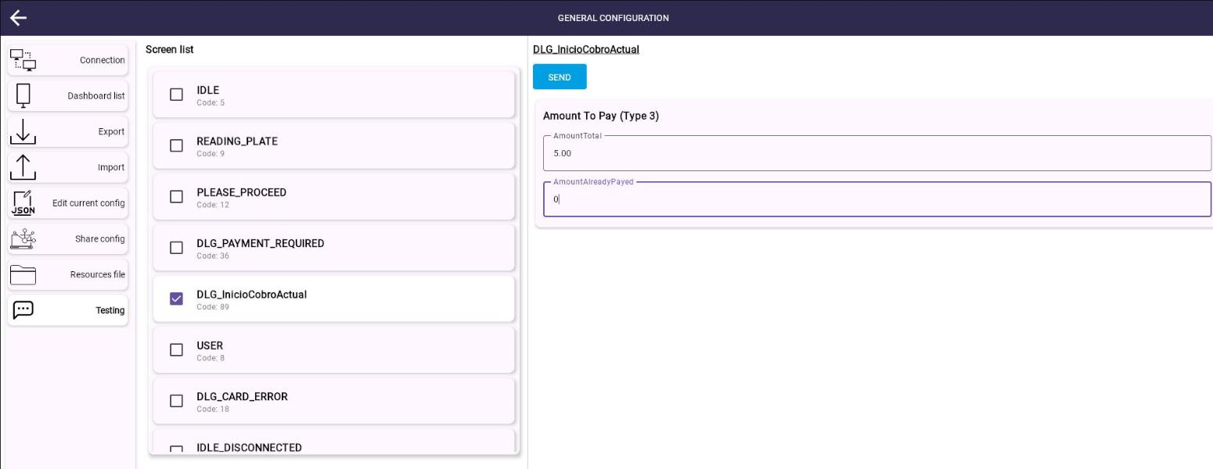
Testing screen: sending the DLG_InicioCobroActual screen with an amount to pay of 5.00

Note:
At the bottom of the side menu there is a selector to change the IP address of the monitor to configure.

Editing the configuration

Configuration editing
- When a graphic element is selected, its JSON code is shown to edit texts, colours, sizes, etc.
- The changes take effect after pressing “UPDATE” and accepting the confirmation message.
- For advanced details, see the document “how_to_edit_the_config.docx”.

Validations and code combinations
For some events, custom messages can be shown according to code combinations (ditTypeCode, dataKey, validValue), for example: to distinguish between subscribers, rotation tickets and Via-T users we have the following configuration:

Configuration | Terminal DIT
ViaT: To show on screen when a vehicle enters or exits with ViaT, the terminal sends the DitType with the code 7 that corresponds to “CurrentCardReader” and another property called “CardReader” with the value “4”. This indicates that the vehicle is entering or exiting with ViaT.  To configure this on the monitor, we can add an “image” element or a “text” element with the properties:  “ditTypeCode” = 7,  “dataKey” = “CardReader”,  “validValue” = 4  This means that the element is shown only when the terminal sends that Dit with those properties | {  "DitType":  {  "DitType": 7,  "DitName": "dit_CurrentCardReader"  },  "Version": 0,  "CardReader": 4  }
Element type: Text | Element type: Image
{  "element-type": "text",  "data": {  "dashboardItemId": "entry-type-value",  "defaultText": "-------",  "ditTypeCode": 7,  "dataKey": "CardReader",  "validValue": 4,  "textSize": 36,  "textColor": "#FFFFFF",  "padding": 0,  "fontWeight": "Medium",  "translations": {  "lang1": "Via-T"  }  }  } | {  "element-type": "image",  "data": {  "dashboardItemId": "viat-image",  "ditTypeCode": 7,  "dataKey": "CardReader",  "validValue": 4,  "fileName": “Via-T_white”,  "height": 30,  "width": 30  }  }

